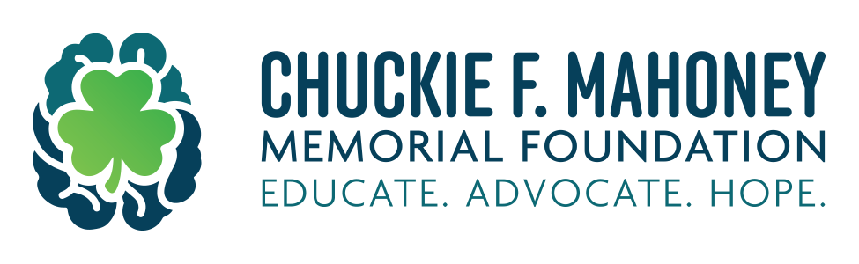

THE CHUCKIE F. MAHONEY FOUNDATION GRANT APPLICATION
2026-27

chuckiefmahoney.org

This grant is to be used to purchase mental health and/or suicide prevention educational materials and or certified trainings, and/or related speakers to mental health and / or suicide prevention for the school year 2026-27.

The foundation will be offering up to 8-$4,000 grants to school districts within Pennsylvania and northern West Virginia.

Applications will be accepted by July 1, 2026.

For questions, contact Charles Mahoney @ 724-470-4000.

Deborah Mahoney @724-371-6944.

Joe Mahoney @ 412-780-7140

Application is attached.

APPLICATION FOR GRANT, 2026-27

Name of School District or Intermediate Unit:
____________________________________________________________________________________

Contact person and title:
____________________________________________________________________________________

Address of school or schools using the money:
____________________________________________________________________________________
____________________________________________________________________________________
____________________________________________________________________________________
Phone number of contact and email address:
____________________________________________________________________________________

Signature of person submitting application:
____________________________________________________________________________________

Explain how this grant money will be useful to your educational mental health curriculum and how you plan to use the money given to your school district, school or IU. Must be used for mental health education or suicide prevention training.

Budget breakdown:

Indicate specifically how money will be spent and cost for each item.

Materials ____________________________________________________________________________________
____________________________________________________________________________________

Speaker
____________________________________________________________________________________
____________________________________________________________________________________

Certified Trainers
____________________________________________________________________________________
____________________________________________________________________________________

Reminder that it must be related to mental health and/or suicide prevention.

Return completed application by July 1, 2026

Debi and Charles Mahoney
286 Ostop Road
Burgettstown, PA 15021

Signature of superintendent or IU director and date

____________________________________________________________________________________

Printed name

____________________________________________________________________________________

